CMPS/IT 490 SENIOR PROJECT PROPOSAL FORM

To register for CMPS/IT 490 a student must submit a hardcopy of this form with the required information, signatures, and dates to Mrs. Tokash (LSC235) and an electronic copy (email to: [cynthia.tokash@scranton.edu](mailto:cynthia.tokash@scranton.edu)). Students whose proposals are submitted prior to the beginning of the semester in which the course runs will be registered for CMPS/IT 490.

Project Title: EZ Workout Builder

Faculty Advisor’s Signature: _________________________________________________ Date:________

Faculty Advisor (Print): __________________________________________________________________

Participant(s)

Name: Myles Spencer RID:R01327243Signature Myles Spencer Date:1/17/22

Name: _______________ RID:_____________ Signature_________________________ Date:_________

Name: _______________ RID:_____________ Signature_________________________ Date:_________

Project Abstract (3 to 5 pages)

Myles Spencer – EZ Workout Builder - 1/28/22

EZ Workout Builder

Overview

EZ Workout Builder is a free web based service that allows people to build a 5 day program that accurately fits their level of fitness knowledge. This website would be great and geared towards people who don’t have extensive knowledge of how to build a proper workout or first time gym goers who may need explanations in order to maximize their workouts.

The Problem

New Year’s has come and gone and the slogan “New Year, New Me” has been thrown around by many people trying to change certain habits in their lives. From changing diets to dedicating time to learning something new, these are meant to be a positive direction a person takes to improve themselves. A common resolution is to start working out for various reasons such as health and wellness or looking for a new physique. However, a lot of newer or inexperienced gym goers don’t know where to start and end up either quitting early in or paying money for a trainer.

(A site offering groups of workouts with no indicator of how to do them)

This is highly discouraging as new goers won’t have a clue on how the exercises impact the parts of their body or how to properly execute a proper movement to target the desired muscle

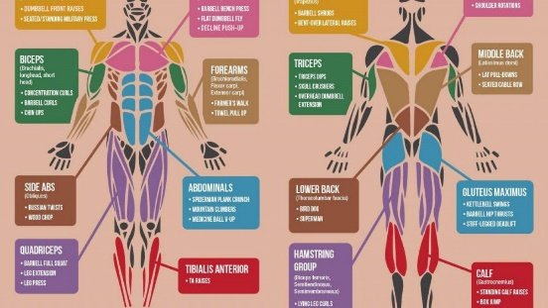

The diagrams also allow for a more focused view but not a general plan of action on how a newbie or someone with no knowledge of what machines or exercises to do in order to successfully complete a full week workout.

Proposed Solution

Inspired by my mother’s recent experiences, EZ Workout Builder is a free web-based service that allows a user to take a short survey and based on the answers, give them a full 5-day circuit of workouts with suggestions on how to maximize their time in the gym. This would give new gym goers the means to find a simple way to create a plan of action and helpful tips to workout. Explanations of how to properly exercise and tips of how to use different variations in order to make their gym experience more fun and accessible. The satisfaction of completing a custom program based on factors like level of activity (little to no activity, a bit active, and very active) would allow for different workouts for each person who uses the service. Access via a computer would be the main way a person uses the EZ Workout Builder so hardware is not a concern. The EZ Workout Builder would be a website supported by a database backend. Workouts are chosen based on a survey on the website and a reach goal would be personalizing a user account so that the workout stays attached to that person’s profile.

Initial Goals Include:  
-survey system that chooses the workout

-each workout comes with a picture of the muscle worked out and an explanation on how to do the set

Additional Goals include:

-user profiles

Research and Feasibility

The timespan available to work on this project is about 3-4 months, but with variable amounts of time I will be able to spend on it. My spring semester will have a lower credit load than I typically take but I also plan to work part-time as well which may impede some time of working on the project. Also, I’m involved in Urban Beats which does take up some of my time. To prep for doing this project, I will take some time to read on website and database construction so I can be more prepared to tackle this project.